

CSF 3133: Antara Muka Laman Web

Lab Report 4
Name: CHONG YU
Matric No.: S76136
Group: K4
Program:
Computer Science (Software Engineering)

Activity 4.2
Code:
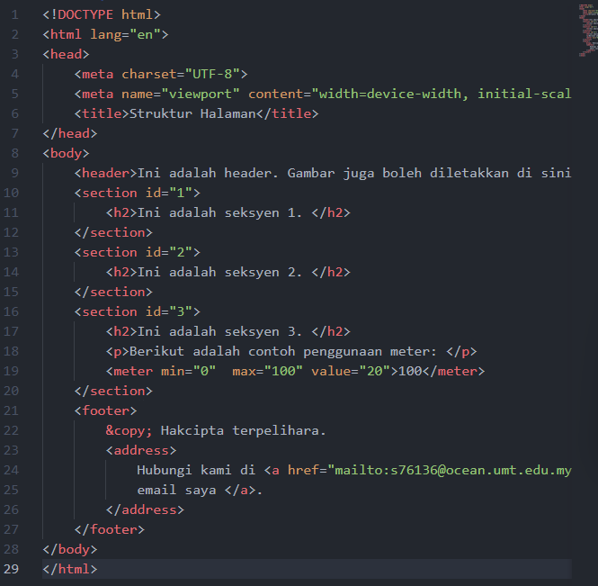

Output:
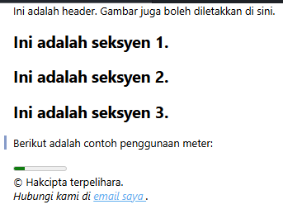

Activity 4.3
Code:
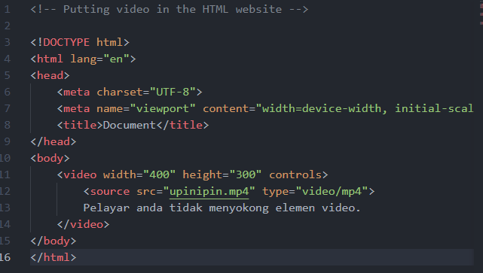
Output:
Width = 400, height = 300
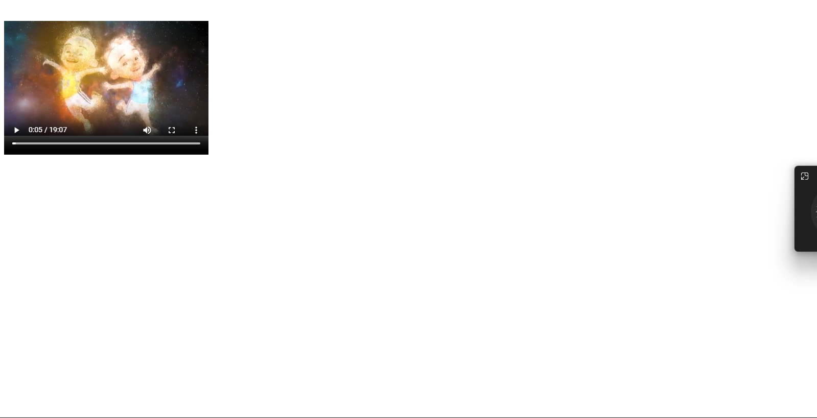

Width = 1000, height = 600
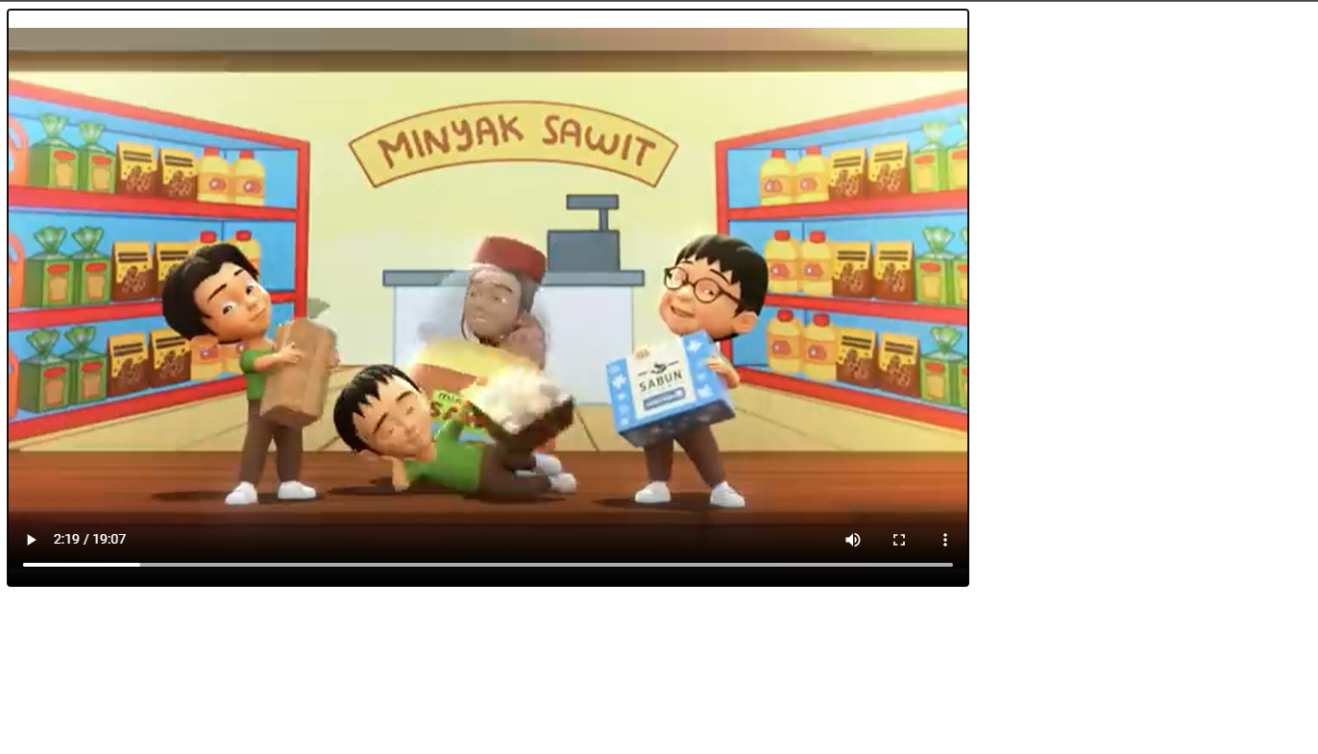
Video format that support by each browser:
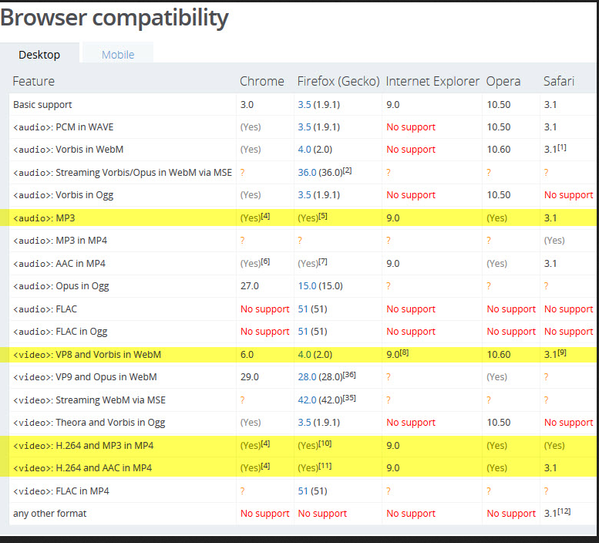

Activity 4.4

Code:
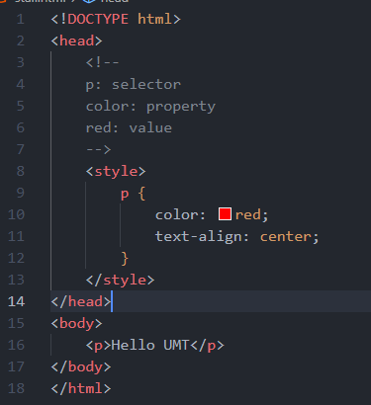s
Output:


Activity 4.5
Code：
StailID.html
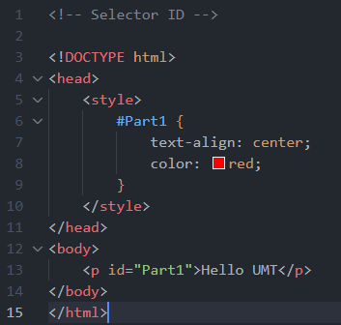

Class.html
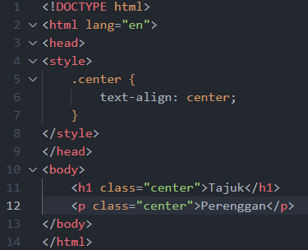

Output:
stailID.html


Class.html


Activity 4.6
Code:
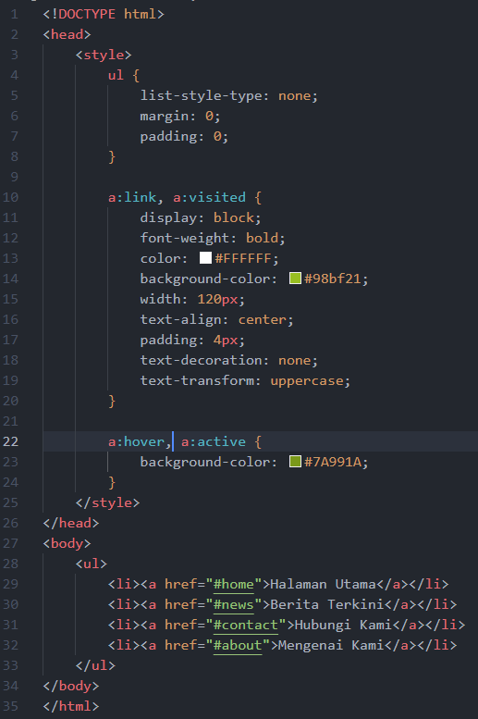
Output:
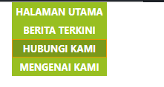

Activity 3.7
Code:
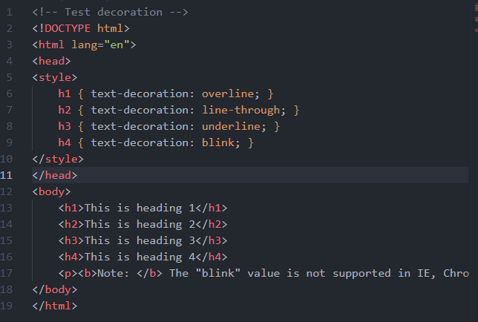
Output:
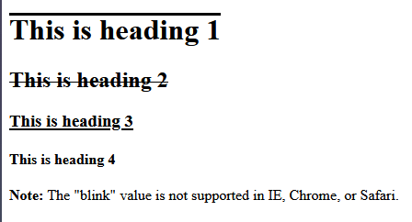

Activity 4.8
Code:
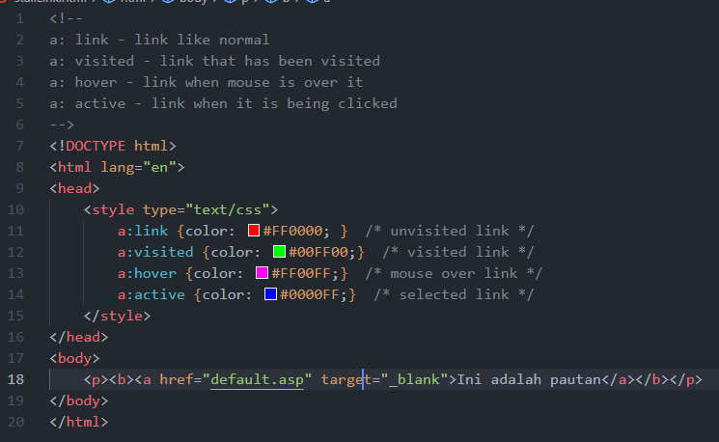
Output:
Link in default color:
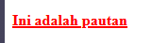
Link when hover:
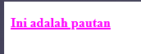
Link when click:
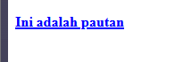

Link after visited: (Some browser did not mark the link that has target = “_blank” as visited)
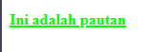

Lab exercise:
Code:
lab4.html
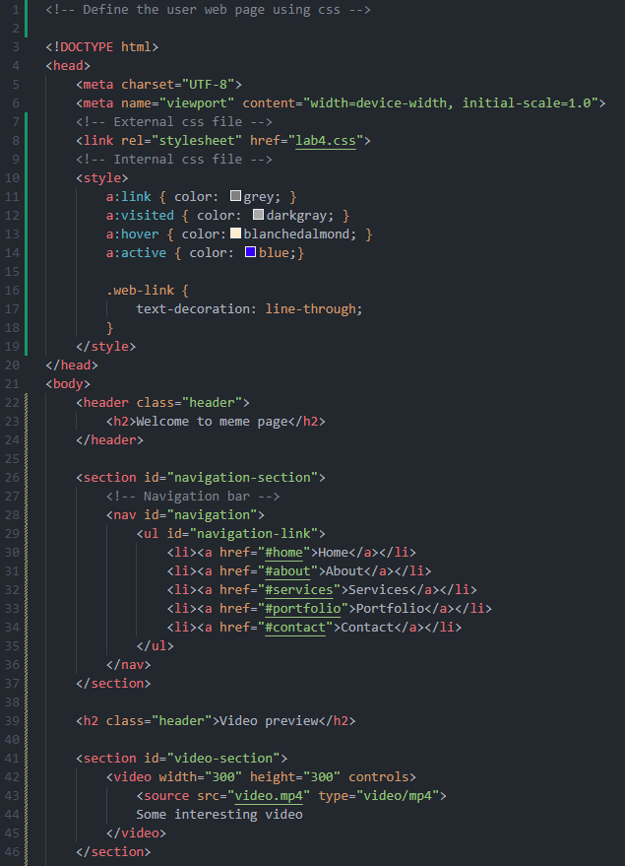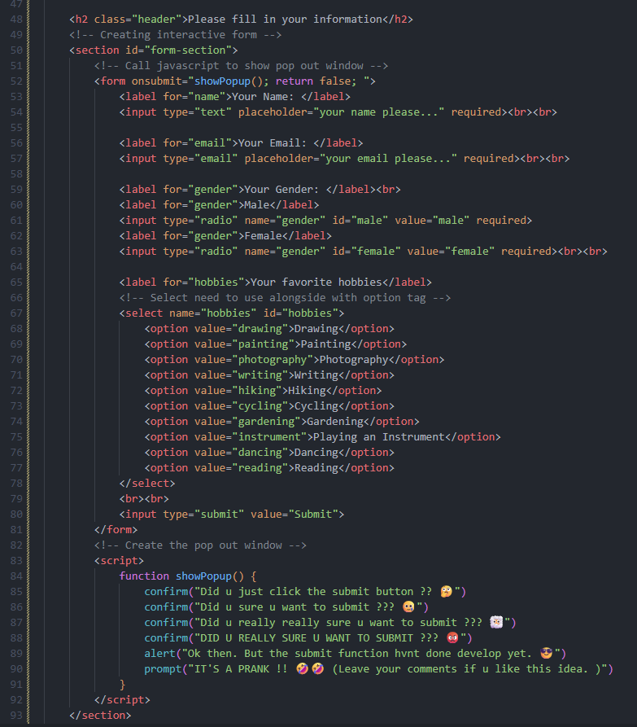
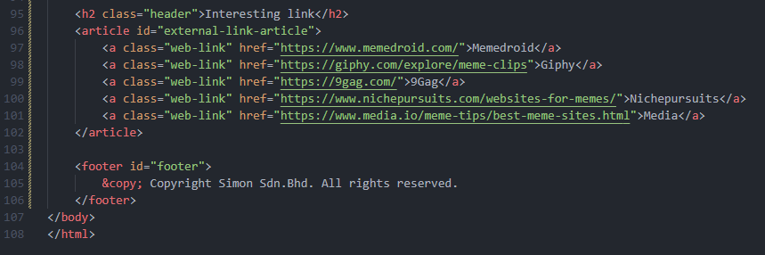

lab4.css
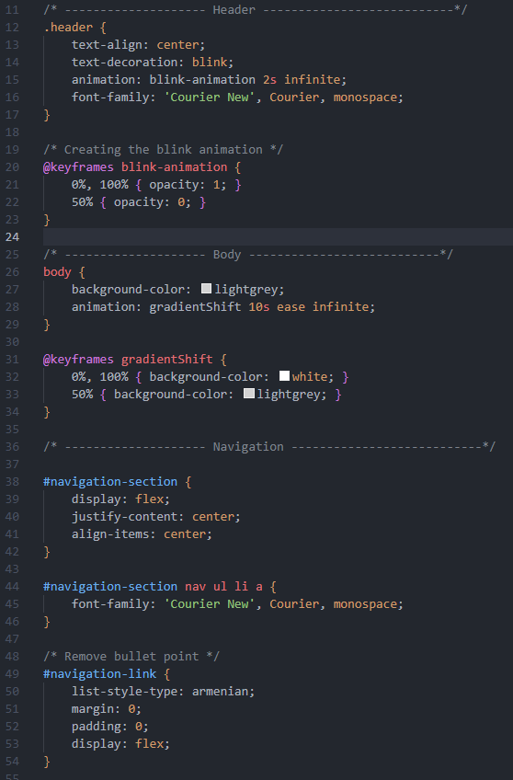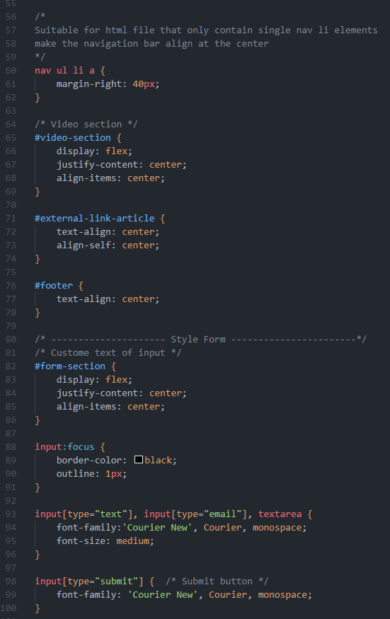
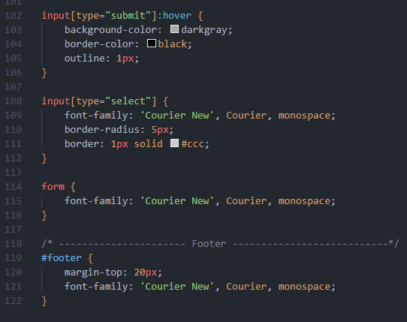

Output:
